**Project 1**

Step1:Create two linux instances,Use the first free linux AMI

ss1:instances list

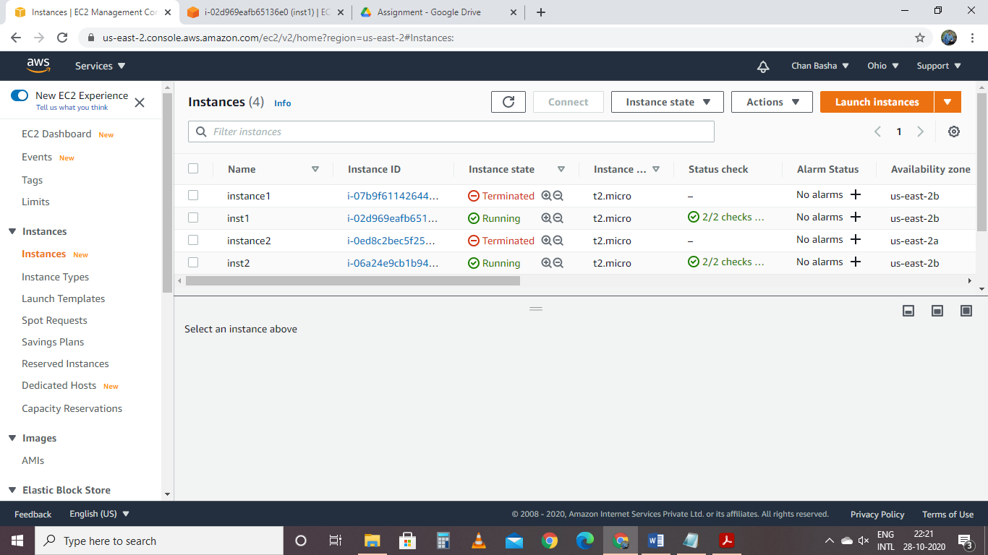

ss2:select a instance and display instance details of server1

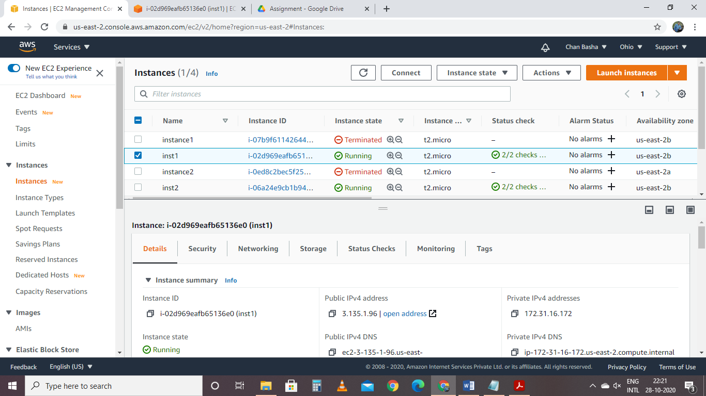

ss3:select a instance and display instance details of server2

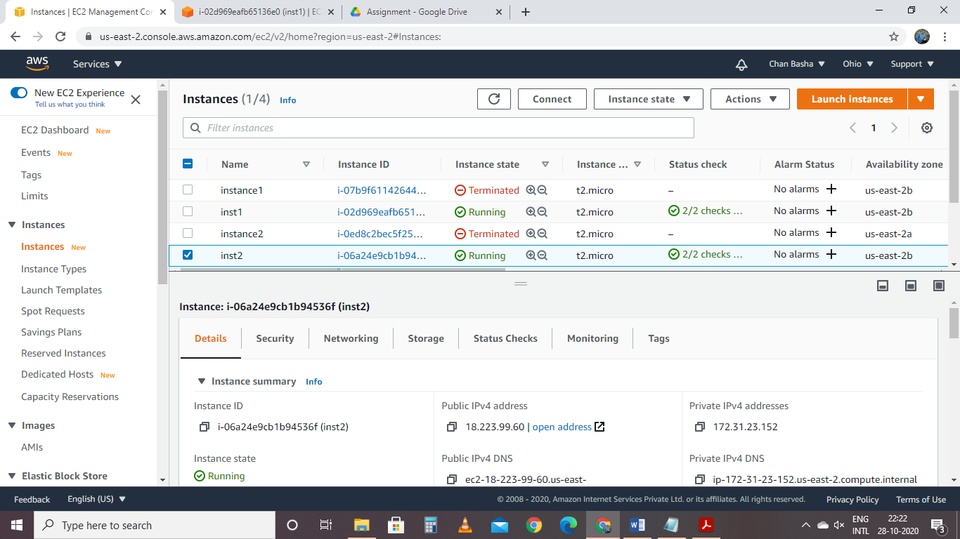

Step2:Launch both instances

ss4:Status:Active running- black screen of both instances

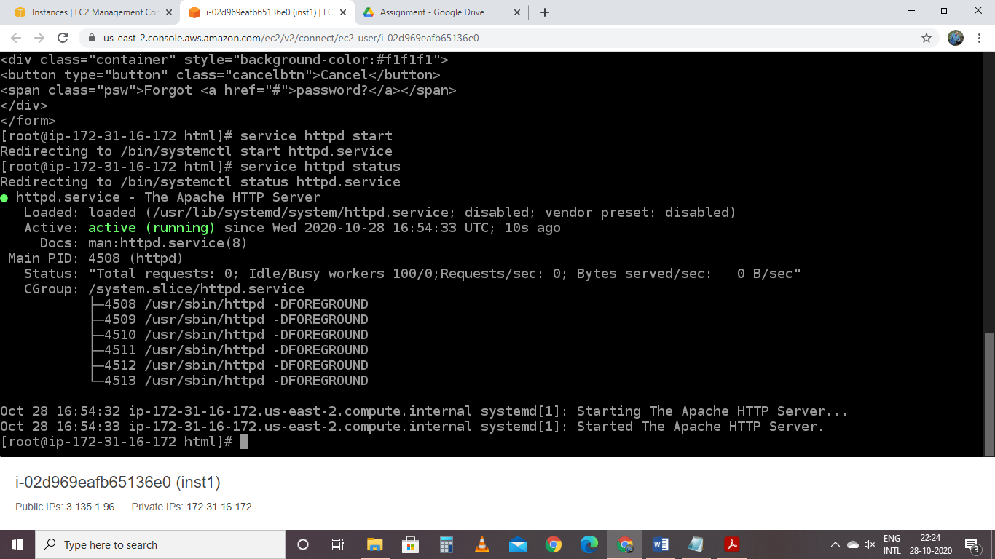

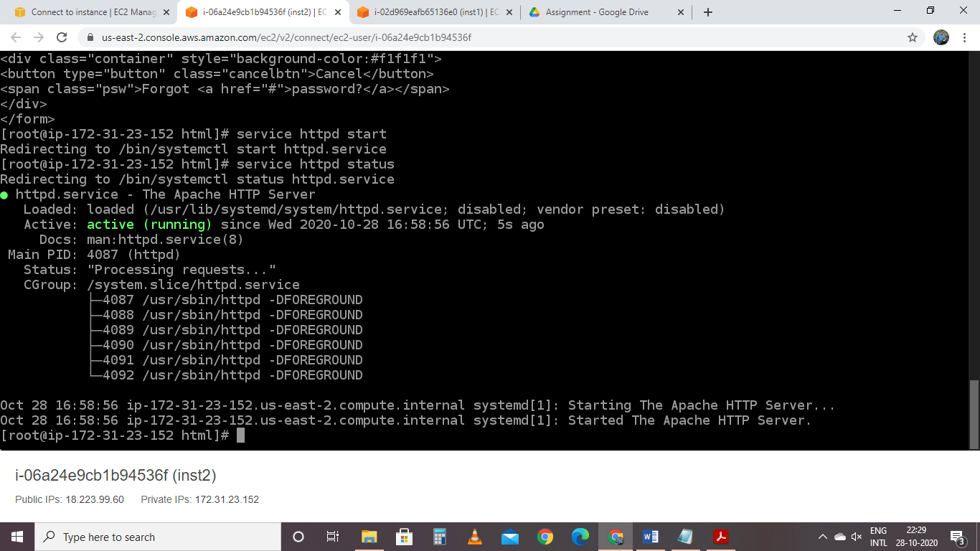

Step4:Checking if application is deployed on both servers by copy pasting the public ip of the

servers into the browser.

ss5:username password page

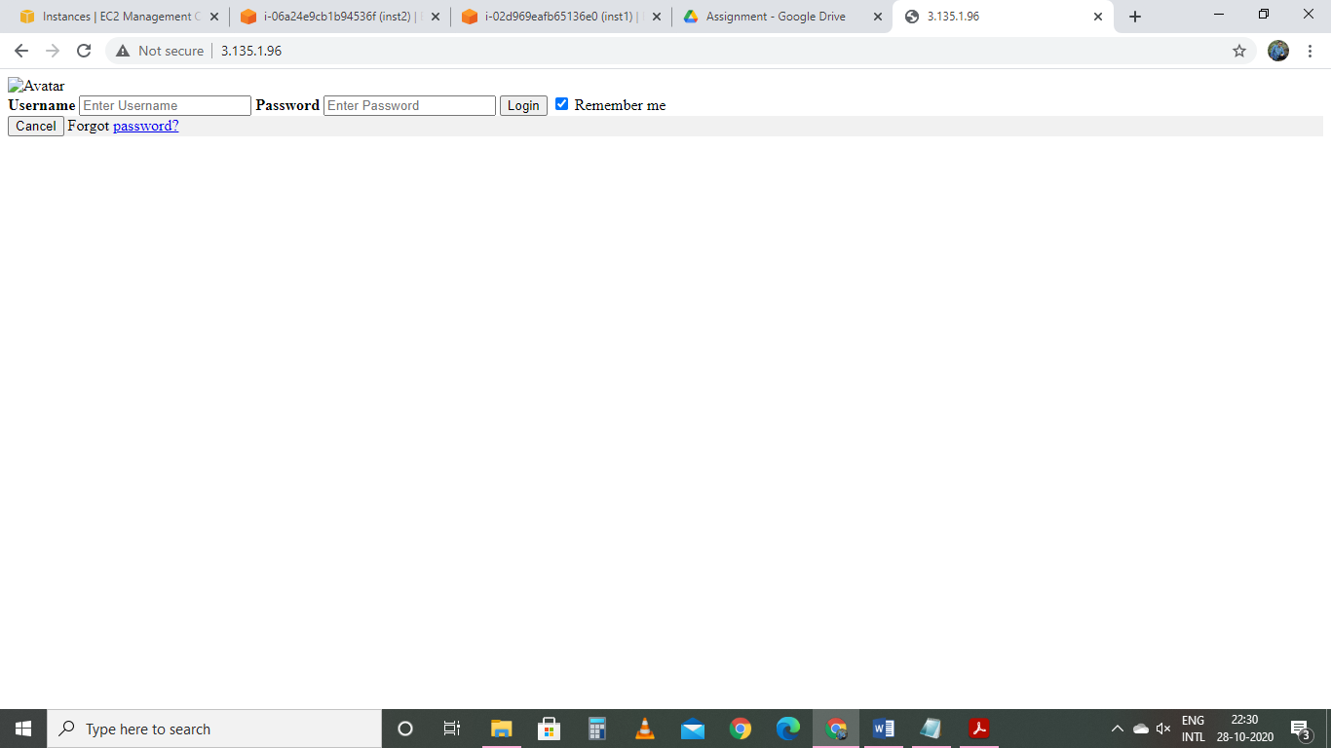

ss6:userid passid

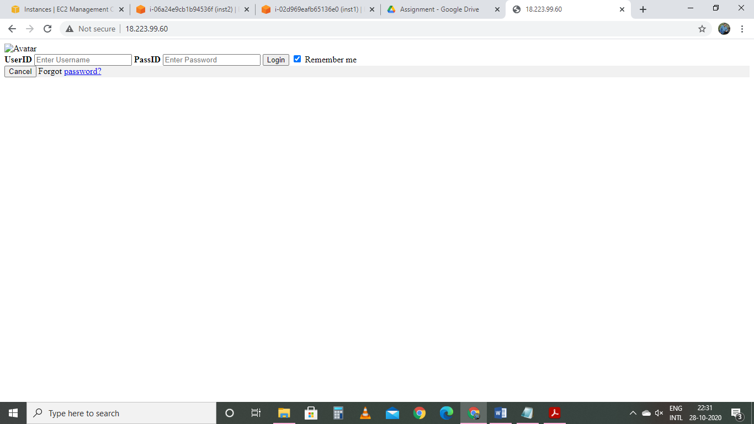

Step5:Create a application Load balancer with the above two instances as targets

ss7:Load balancer screenshot

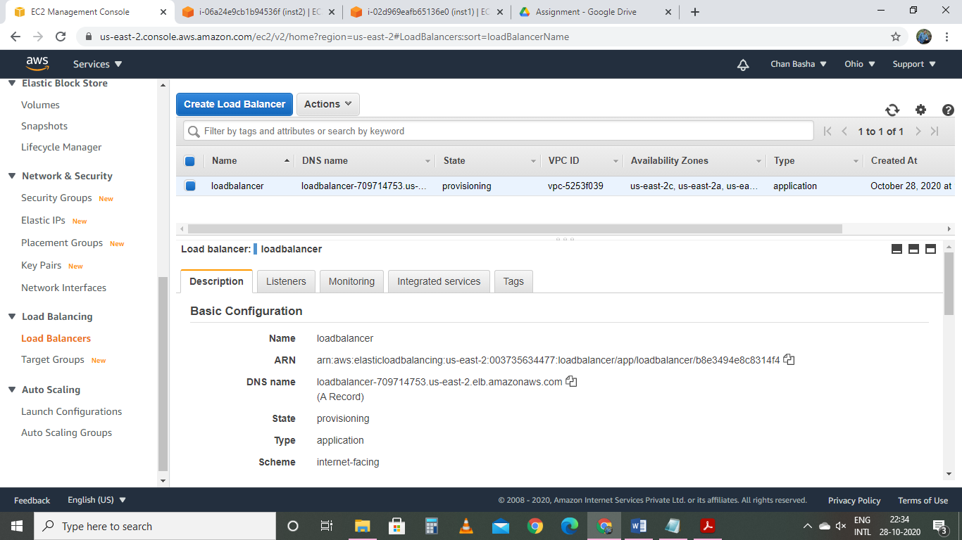

Step6:Check the functioning of ELB using the DNS of the ELB

use the dns

ss8:reply from server1

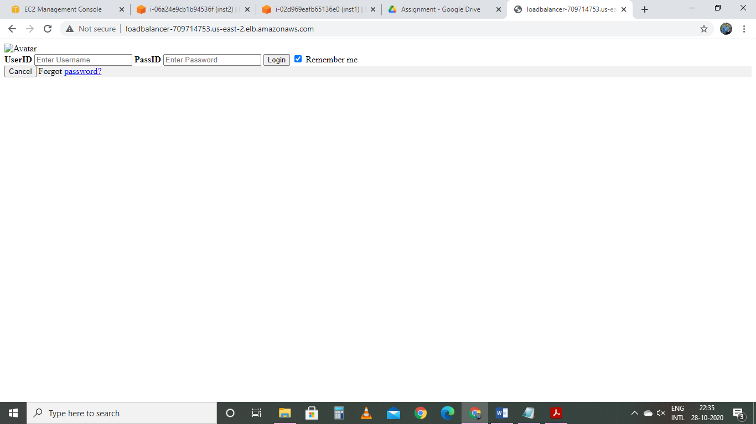

ss9:reply from server2

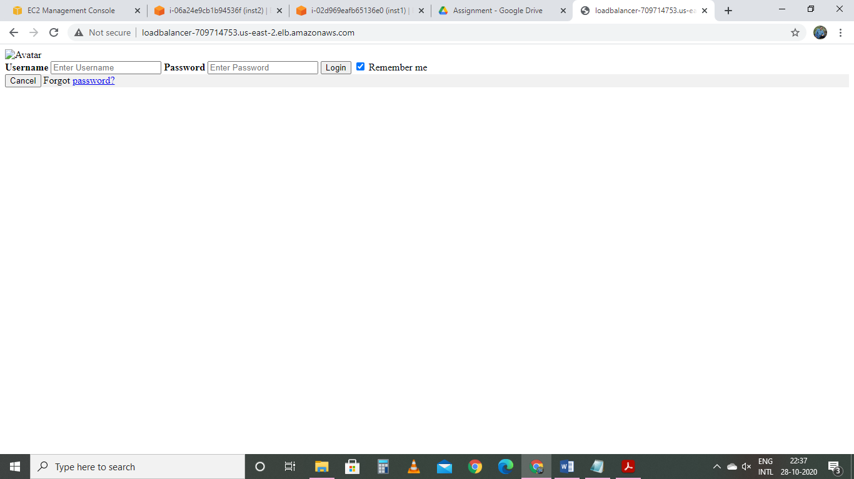

Project 2

Creating a User Pool in AWS Cognito

1 Creating a user pool

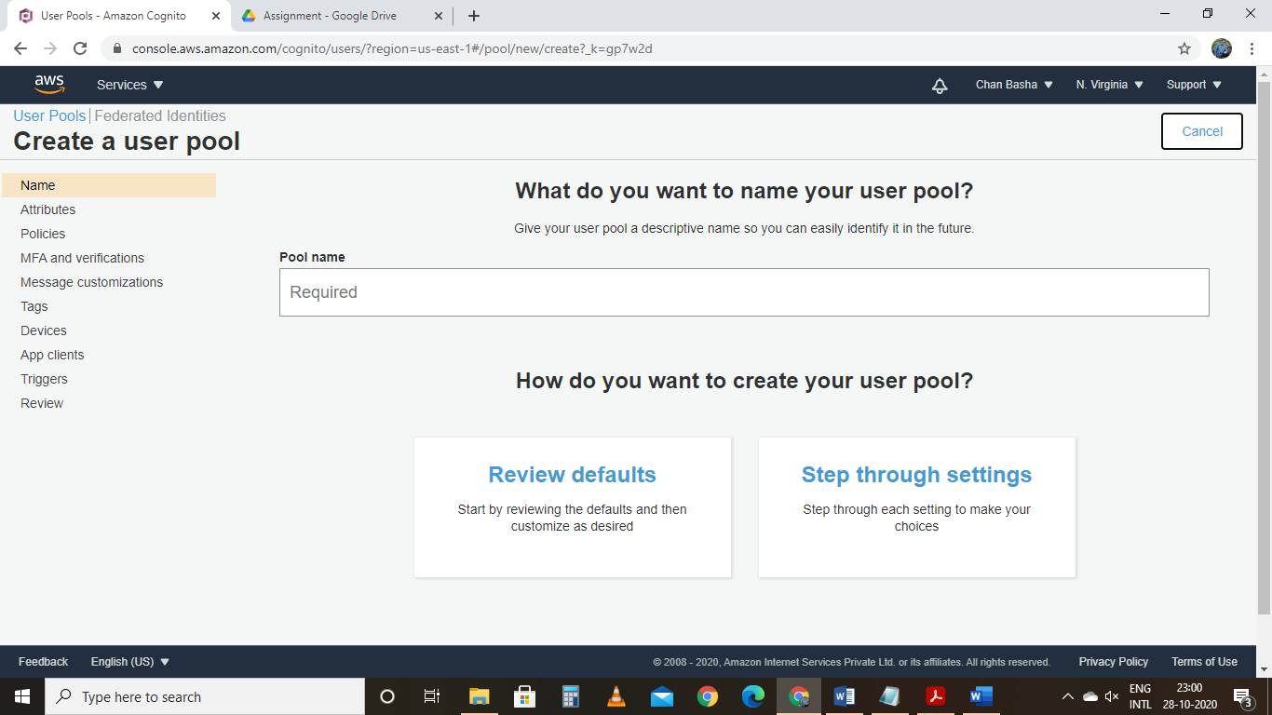

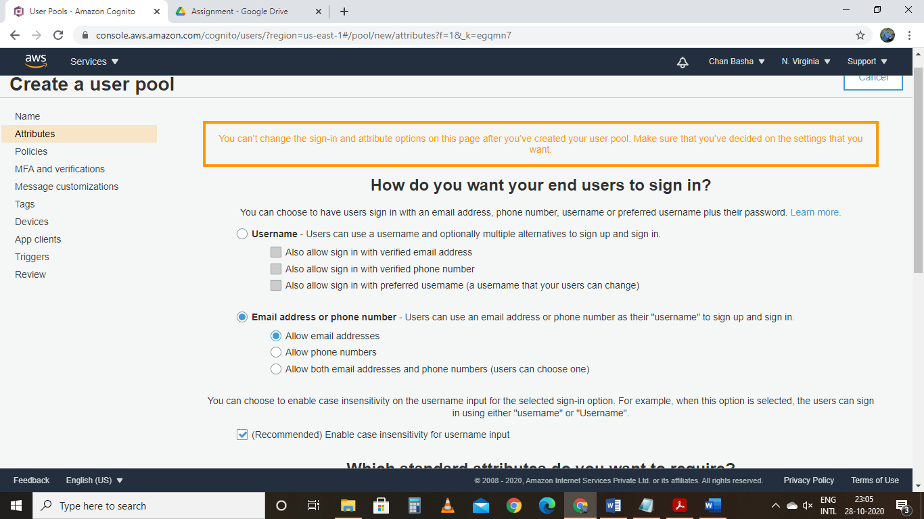

Standard attribute

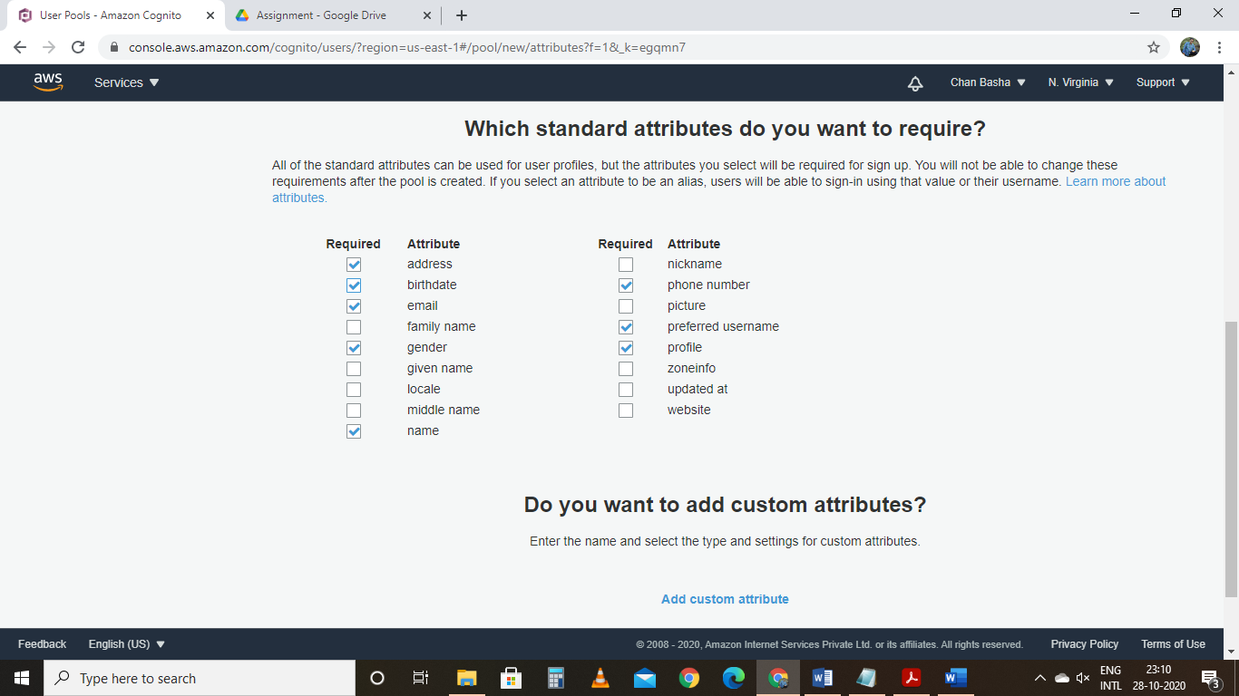

Policies

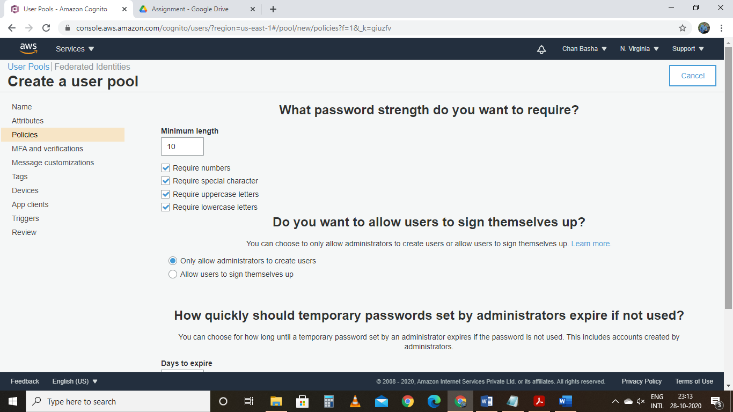

MFA

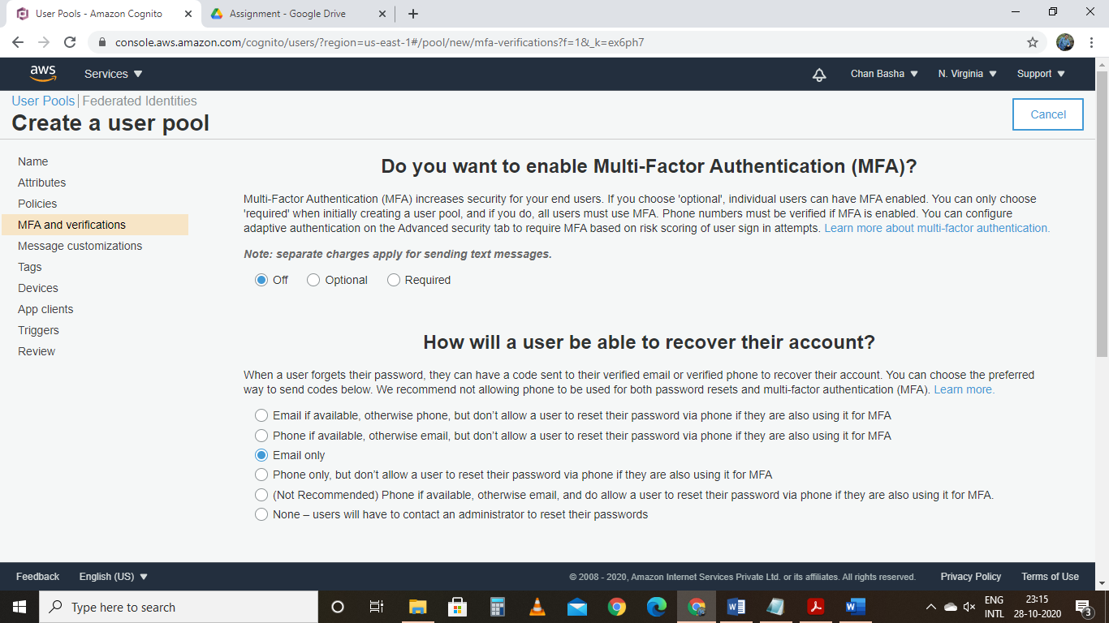

Tags

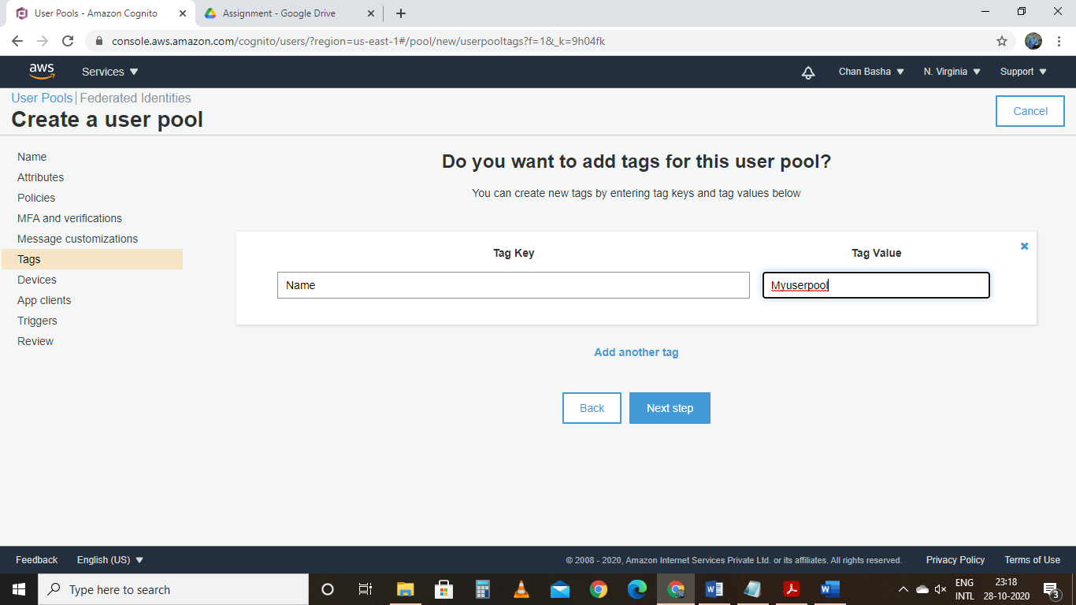



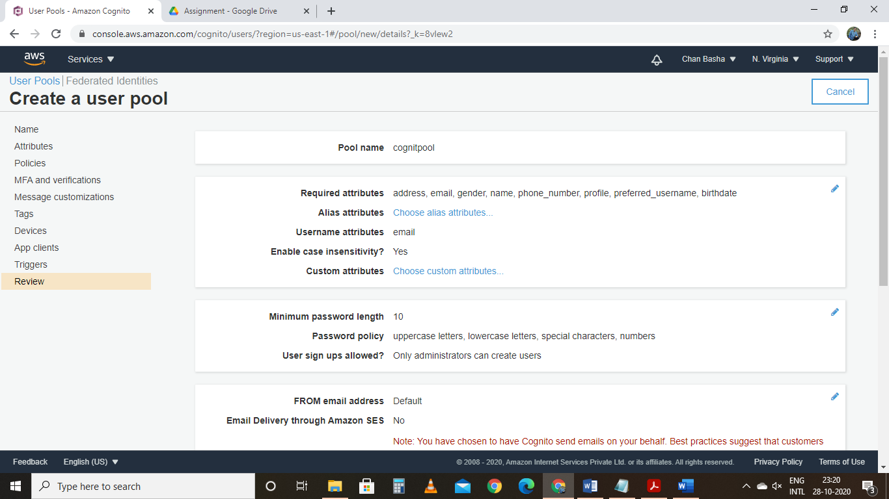

User pool created successfully

